SUPPORTING INFORMATION FOR

An Analytical Screening Platform to Differentiate Acute and Prolonged Exposures of PFAS on Invasive Cellular Phenotypes

Ryan A. Lidgett ª, Abel A. Miranda Buzetta ª, J. Ian Baker ª, Pearl Dang ª,
Amy L. Oldenburg ^{b,c,d}, and Matthew R. Lockett ^{a,c} *

ª Department of Chemistry, University of North Carolina at Chapel Hill, 125 South Road, Chapel Hill, NC 27599-3290
^{b} Department of Physics and Astronomy, University of North Carolina at Chapel Hill, 120 E. Cameron Avenue, Chapel Hill, NC 27599-3255
^{c} Lineberger Comprehensive Cancer Center, University of North Carolina at Chapel Hill, 450 West Drive, Chapel Hill, NC 27599-7295
^{d} Biomedical Research Imaging Center, University of North Carolina at Chapel Hill, 125 Mason Farm Road, Chapel Hill, NC 27599-7513

* author to whom correspondence should be addressed: mlockett@unc.edu

Table of Contents Page
Detailed protocol for invasion assay setup and analysis S3

Figure S1 Positional invasion variation datasets S5
Figure S2 M231 toxicity (monolayer) to increasing concentrations of PFAS S6
Figure S3 MCF7 toxicity (monolayer) to increasing concentrations of PFAS S7
Figure S4 MCF7 toxicity (3D cultures) to 10 µM PFAS S8
Figure S5 M231 invasion dataset: acute exposure to 10 µM PFAS S9
Figure S6 M231 invasion dataset: acute exposure to increasing PFAS S10
concentrations
Figure S7 MCF7 invasion dataset: acute exposures to increasing PFAS S11
concentrations
Figure S8 MCF7 invasion dataset: acute exposure to 10 µM of S12
non-fluorinated PFAS analogs

Detailed Protocol

- Prepare paper scaffolds as outlined in Kenney et al. or Sitte et. al.^{1, 2} Our group website also has an overview of the scaffold preparation process with pictures.
https://lockettgroup.weebly.com/cell-seeding-procedures.html
  - Sterilize scaffolds by ethylene-oxide sterilization (preferable) or with overnight UV irradiation.
  - Store scaffolds in a sterile environment until needed.
- Stock solutions
  - Prepare a CellTracker-Red working stock in DMSO when needed, following the manufacturer’s procedure. Store the remainder of the working stock at -20 ºC.
  - Prepare PFAS working stock solutions (1000x dosing concentration) in ethanol. A vehicle control (ethanol only) should also be prepared. Store the stock solutions at 4 ºC and prepare fresh every other week.
- Cell maintenance
  - For acute exposure. Maintain the cells as a monolayer under standard culture conditions. Exchange medium every 48 h. When 80% confluent, wash the cells with 1X DPBS and incubate in TrypLe solution for 5 min.
  - For prolonged exposure. Maintain the cells as a monolayer under standard culture conditions in medium containing the appropriate concentration of PFAS (0.1% v/v ethanol). Exchange medium every 48 h. When 80% confluent, wash the cells with 1X DPBS and incubate in TrypLe solution for 5 min. Passage the cells at a defined cell number (e.g., 0.3x10⁶ cells/well for a 6-well plate). Maintain the cells in PFAS-containing medium for five passages.
- Setting up invasion assay
  - Resuspend the freshly trypsinized cell pellet in 5 mL of 1X DPBS. Add 10 µL of CellTracker-Red stock solution (final concentration, 2.9 µM) and rock at room temperature for 20 min.
  - Centrifuge at 1000 xg for 5 min, resuspend the cell pellet in 1 mL of culture medium and determine the number of live cells after Trypan Blue staining.
  - Calculate the total number of live cells needed for the assay (4.0x10⁵ cells/mL/scaffold). Add the corresponding volume of cell suspension to a 1.5 mL tube. Centrifuge at 1000 xg for 5 min.
  - Resuspend the cell pellet in the appropriate volume of Matrigel. Keep the cell suspension on ice throughout the setup to ensure the Matrigel does not solidify.
  - Pipette 0.5 µL of cell suspension into the center of the paper scaffold. Use the 2.5 µL micropipette tip to distribute the Matrigel in the scaffold evenly. Change your pipette tip often, preferably after every scaffold.
  - Allow the scaffold to dry for approximately 5 s before placing it in a dish containing culture medium. For acute exposure studies, use standard culture medium. For prolonged exposure studies, use PFAS-containing culture medium.
  - Repeat step f until the desired number of paper zones are prepared. Ensure the cell suspension is evenly mixed throughout the process, triturating the Matrigel after preparing five zones.
- Incubate the zones for a minimum of 4 h under standard culture conditions.
- Prepare the 96-well plate
  - Design the plate layout to ensure the different conditions are randomly distributed.
  - Add 100 µL of PFAS-containing culture medium to each well.
  - Fill the remaining wells of the plate with 200 µL of 1X PBS
- Transfer one scaffold into each well.
- Incubate the well plate under standard culture conditions for 24 h. Remove the scaffolds from each well and count the cells attached to the plate bottom.
  - If there are a large number of unattached cells, aspirate and exchange the medium before counting.
  - Count cells using a fluorescence microscope or imaging cytometer.
  - To confirm the viability of the attached cells, stain with a live-dead stain that allows visualization and counting of the CellTracker-Red dye plus any additional stains.

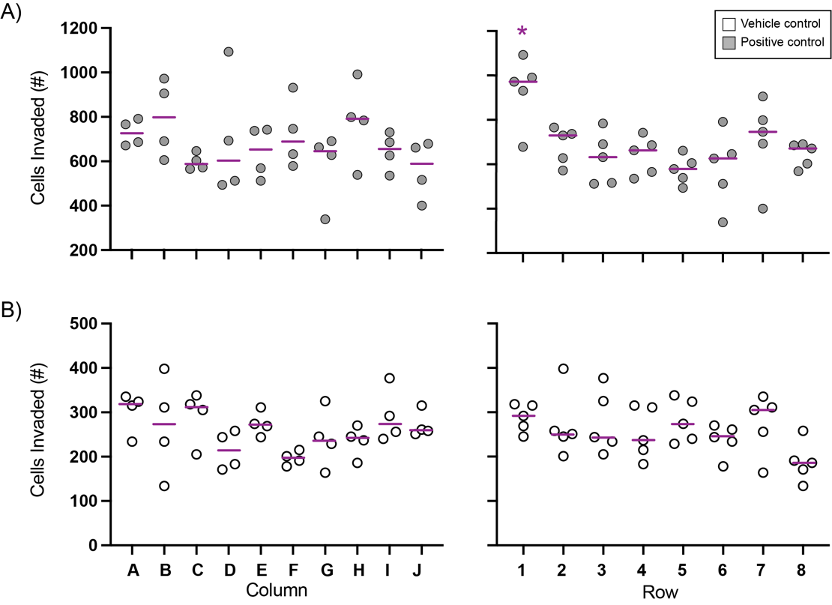

Figure S1. Positional invasion variation across a 96-well plate, formatted in a checkerboard pattern of vehicle and positive control wells. Each data point represents a 24-h invasion assay for a paper scaffold deposited with 2.0x10⁴ fluorescently labeled MCF7 cells suspended in Matrigel. The scaffolds were prepared en masse and distributed throughout the plate randomly to alleviate experimental setup biases. A) (left) column and (right) row data points for positive control-containing wells. B) (left) column and (right) row data points for vehicle control-containing wells. The purple bars in each plot represent the median value. * p < 0.05.

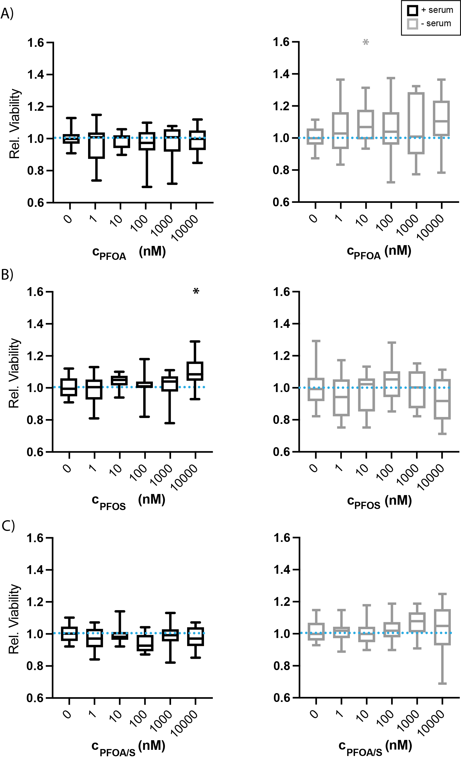

Figure S2. Relative viability of M231 cells after a 48-h exposure to increasing concentrations of A) PFOA, B) PFOS, or C) and an equimolar mixture of the two (PFOA/S) in culture medium (left) with serum and (right) without serum. Cell viability was determined by comparing the number of cells attached to the bottom of the well plate at the start of the experiment and after the 48-h exposure. Each box-and-whisker plot represents the full range of data collected from 18 replicates across three separate cell passages. The blue line in each plot indicates the normalized value of the appropriate vehicle control. * p < 0.05.

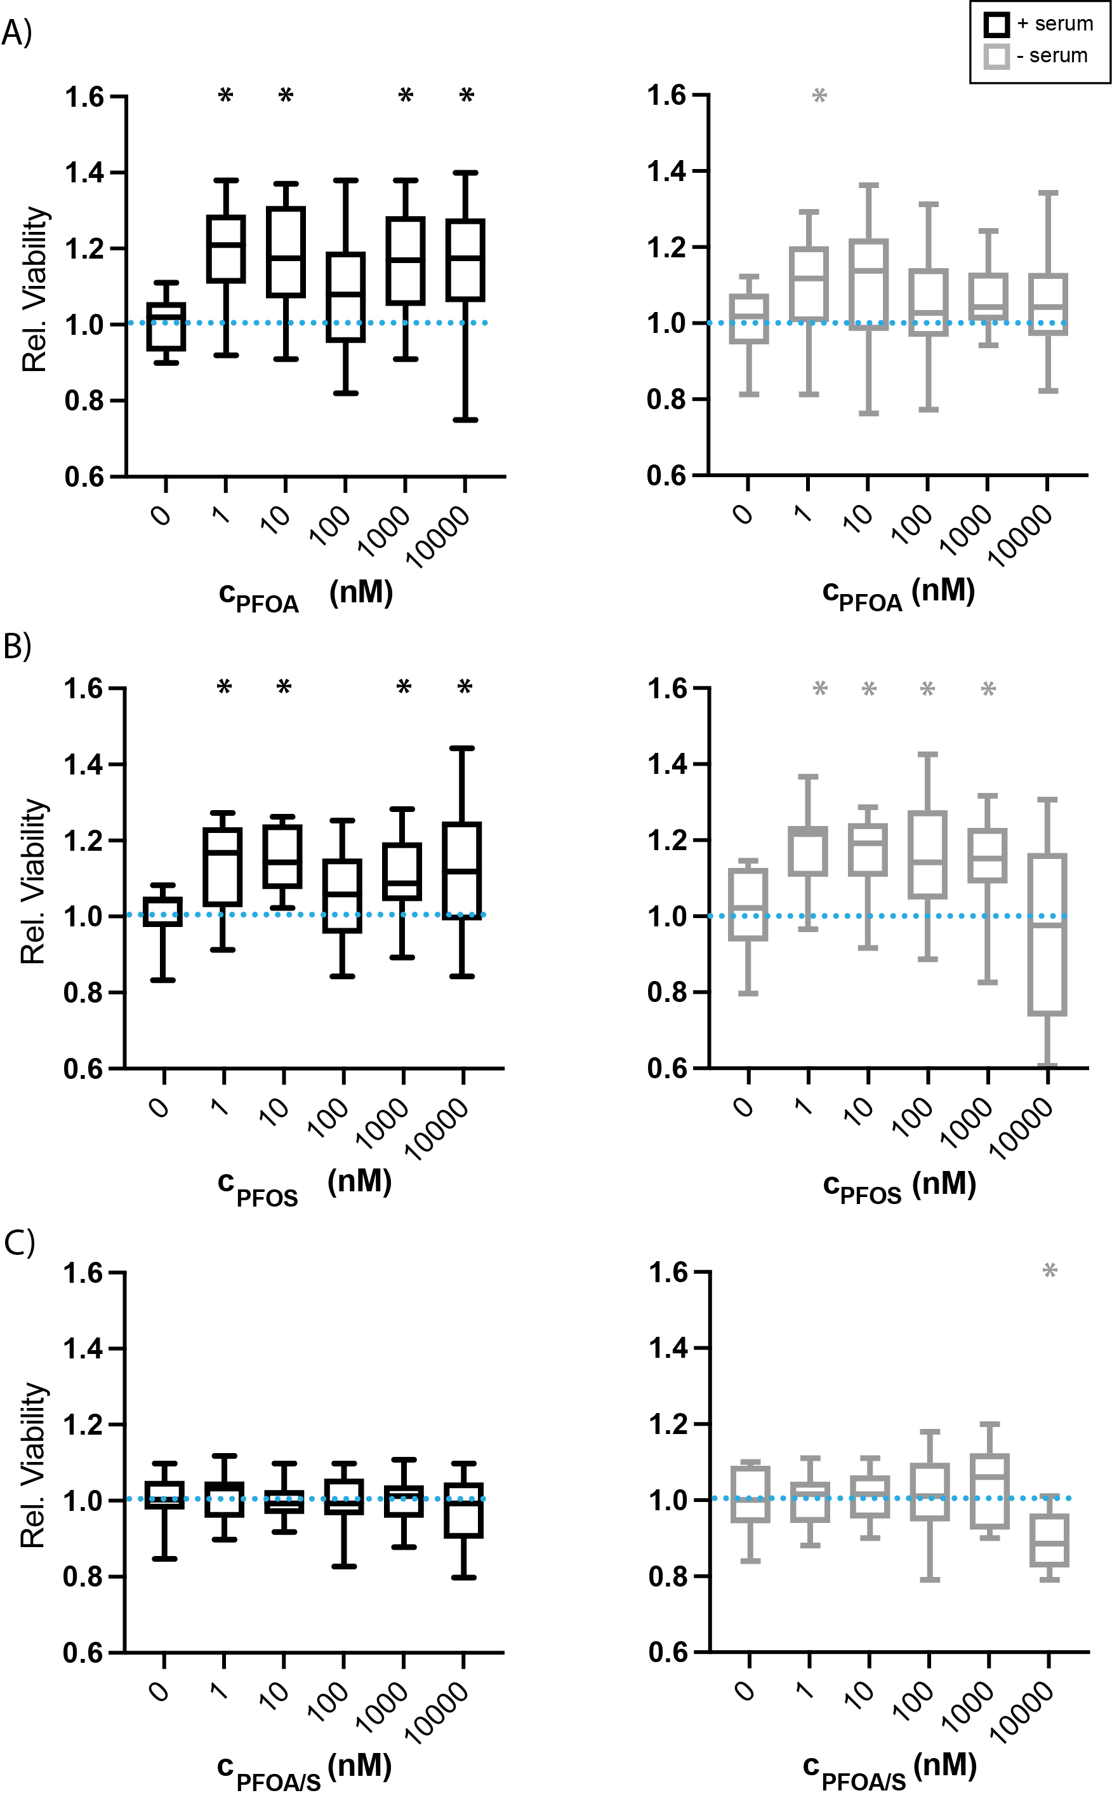

Figure S3. Relative viability of MCF7 cells after a 48-h exposure to increasing concentrations of A) PFOA, B) PFOS, or C) and an equimolar mixture of the two (PFOA/S) in culture medium (left) with serum and (right) without serum. Cell viability was determined by comparing the number of cells attached to the bottom of the well plate at the start of the experiment and after the 48-h exposure. Each box-and-whisker plot represents the full range of data collected from 18 replicates across three separate cell passages. The blue line in each plot indicates the normalized value of the appropriate vehicle control. * p < 0.05.

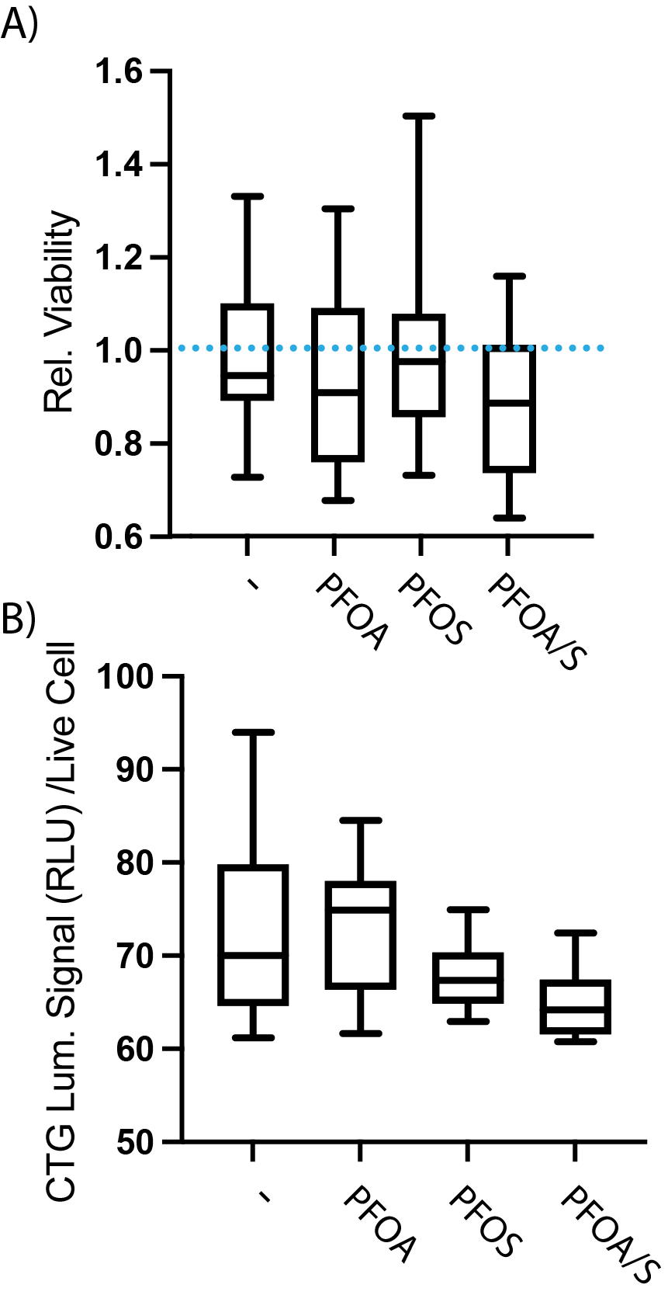

Figure S4. A) Relative viability of MCF7 cells in the paper scaffolds after a 24-h exposure to 10 µM PFOA, PFOS, or PFOA/S in serum-free medium. The scaffolds were deposited with 2.0x10⁴ MCF7 cells suspended in Matrigel and incubated in culture medium with serum for at least 4 h before transferring to a 96-well plate containing the PFAS or vehicle control solutions. Cell viability was determined with the CellTiter-Glo assay, according to the manufacturer’s directions. Each box-and-whisker plot represents the full range of data collected from 12 replicates across two separate cell passages. The blue line in each plot indicates the normalized value of the appropriate vehicle control. B) CTG signal from 1.0x10⁴ MCF7 cells deposited in a 96-well plate. After overnight attachment in culture medium with serum, cells were exposed to 10 µM PFOA, PFOS, or PFOA/S in 1X PBS for 5 minutes before analysis with the CellTiter-Glo assay. Each box-and-whisker plot represents the full range of data collected from 12 replicates across two separate cell passages. * p < 0.05.

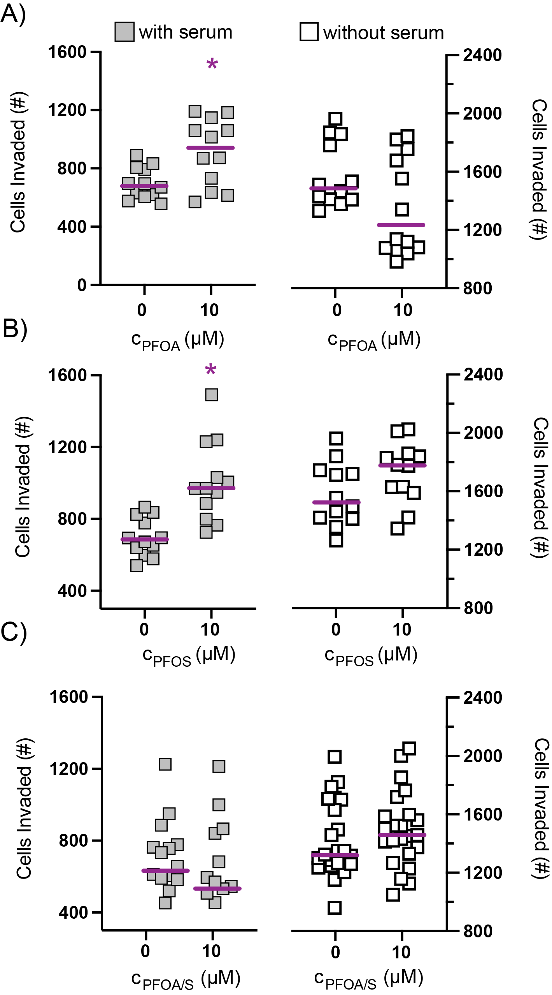

Figure S5. Invasion data for M231 cells after acute exposure of vehicle control versus 10 µM A) PFOA, B) PFOS, or C) PFOA/S mixture. Scaffolds deposited with 2.0x10⁴ fluorescently labeled M231 cells suspended in Matrigel were placed in a 96-well plate, incubated for 24 h, and the cells attached to the bottom of the plate were counted with an imaging cytometer. Each dataset represents 18 replicate invasion assays collected across three separate cell passages. * p < 0.05.

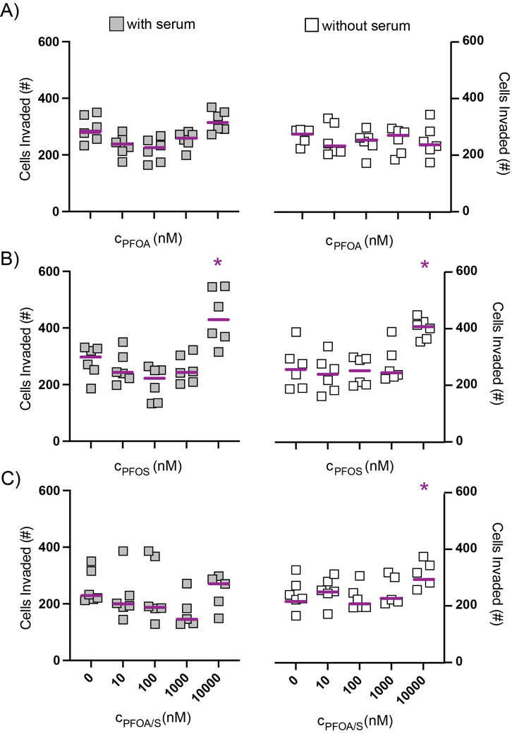

Figure S6. Invasion data for M231 cells after acute exposure of vehicle control versus 10 µM A) PFOA, B) PFOS, or C) PFOA/S mixture. Scaffolds deposited with 2.0x10⁴ fluorescently labeled M231 cells suspended in Matrigel were placed in a 96-well plate, incubated for 24 h, and the cells attached to the bottom of the plate were counted with an imaging cytometer. Each dataset represents at least six replicate invasion assays collected across two cell passages. * p < 0.05.

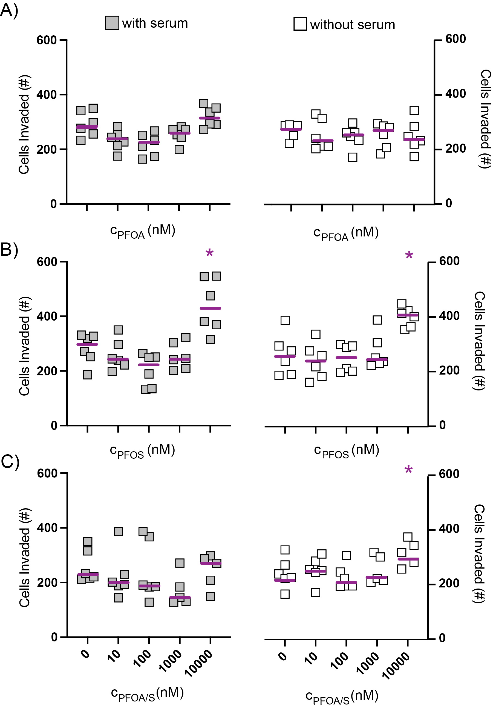

Figure S7. Invasion data for MCF7 cells after an acute exposure to increasing concentrations of A) PFOA, B) PFOS, or C) or PFOA/S. Scaffolds deposited with 2.0x10⁴ fluorescently labeled M231 cells suspended in Matrigel were placed in a 96-well plate, incubated for 24 h, and the cells attached to the bottom of the plate were counted with an imaging cytometer. Each dataset represents at least five replicate invasion assays collected from the same cell passage. * p < 0.05.

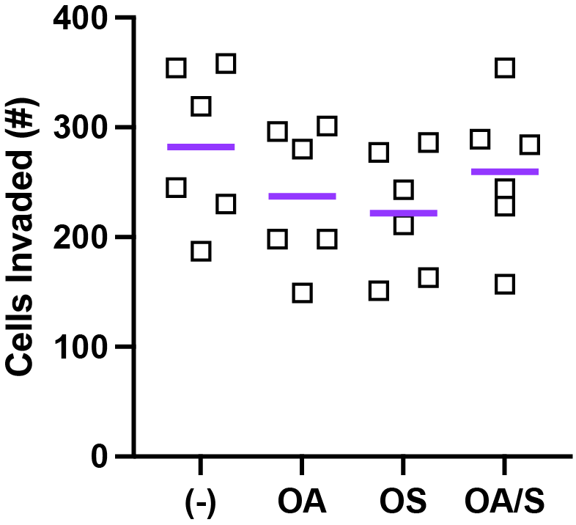

Figure S8. Invasion data for MCF7 cells after an acute exposure of vehicle control versus 10 µM A) octanoic acid (OA), B) octanesulfonic acid (OS), or C) or an equimolar mixture of the two (OA/S). Scaffolds deposited with 2.0x10⁴ fluorescently labeled M231 cells suspended in Matrigel were placed in a 96-well plate, incubated for 24 h, and the cells attached to the bottom of the plate were counted with an imaging cytometer. Each dataset represents six replicate invasion assays collected across a single cell passage. * p < 0.05.

(1) Kenney, R. M.; Loeser, A.; Whitman, N. A.; Lockett, M. R. Paper-based Transwell assays: An inexpensive alternative to study cellular invasion. Analyst 2019, 144 (1), 206-211. DOI: 10.1039/c8an01157e.
(2) Sitte, Z. R.; DiProspero, T. J.; Lockett, M. R. Evaluating the impact of physiologically relevant oxygen tensions on drug metabolism in 3D hepatocyte cultures in paper scaffolds. Curr. Protoc. 2023, 3 (2), e662. DOI: 10.1002/cpz1.662.

